Date:
Participant Details
Surname: | Given name(s): |  | Sex : Male Female  Intersex or Indeterminate
Preferred name: |  |  | Date of Birth:
Carer details
Full Name: |  |  | Mobile No:
Emergency Details (Primary Contact)
Contact Name: |  | Relationship:
Home Phone No: |  | Mobile No:
GP Medical Contact
Clinic Name: |  | Email Address:
Surname: |  | First Name:
Address:
Telephone Number: |  | Mobile Phone Number:

Staff trained and competent to assist.
Doctor’s orders are completed.
Condition of participant
Symptoms of participant
Goal of intervention
Potential Risks, Incident, and Emergency
Treatment plan
Information which must be reported to a health practitioner
Specific instructions, details and considerations for management and changes
Role of Others in the Health Care Plan/Agreed Partnership Actions
Name | Relationship | Responsibilities

Participant’s or Participant’s Representative’s Name |  | Date |  | Signature
Health Care Plan completed by: |  | Date |  | Signature

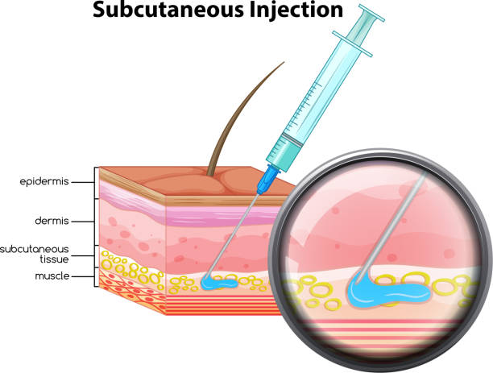

Medication | Date | Dosage | Site given/route given | Staff initials | Participant/or  Advocate initials | Comments

